**Hands-on Lab : Getting Started with Cognos Dashboard Embedded**

**Estimated time needed:** 20 minutes

IBM Cognos Dashboard Embedded (CDE) is an AI-fueled business intelligence service that supports the entire data analytics cycle, from discovery to operationalization. It provides users with data discovery capabilities to visually explore and interact with their data to identify the key insights for improving data driven decisions. Users can perform data discovery and then quickly assemble that information into interactive, visually appealing dashboards; all without the need of formal training.

In this lab, first you will learn how to login to IBM Cloud Pak for Data platform through IBM Cloud and create a project there. Next, you will learn how to add a Cognos Dashboard Embedded (CDE) service and upload external data files to your project(supports CSV file only). Finally, you will learn general navigation around the CDE user interface (UI), and how to start a new dashboard with a template in CDE, populate it with a data visualization as well as save the dashboard.

**Software Used in this Lab**

Since for the assignment of this module you will be using IBM Cognos Dashboard Embedded (CDE), so in this lab you will get started with IBM Cognos Dashboard Embedded (CDE) Lite plan service through IBM Cloud as this is available **at no charge for 50 sessions/month**. A session is a **60 minutes period** where users can perform unlimited interactions with an embedded dashboard. Lite plan services are deleted after **30 days of inactivity**.

**Dataset Used in this Lab**

The dataset used in this lab comes from the following source: <https://www.kaggle.com/kyanyoga/sample-sales-data> under a [**CC0: Public Domain license**](https://creativecommons.org/publicdomain/zero/1.0/).

**Objective**

After completing this lab, you will be able to:

* Login to IBM Cloud Pak for Data platform through IBM Cloud
* Create a project in IBM Cloud Pak for Data
* Add a Cognos Dashboard Embedded (CDE) service to your created project
* Navigate around the Cognos Dashboard Embedded (CDE) user interface
* Upload external data files to your created project (Supports .CSV files only)
* Start a new dashboard with a dashboard template and populate it with a data visualization

**Exercise 1 : Login to IBM Cloud Pak for Data and Create a Project**

In this exercise, you will how to login to IBM Cloud Pak for Data platform through IBM Cloud and create a project there.

**Task A : (optional) Create an Instance of Watson Studio / Cloud Pak for Data**

* **If you already have an instance of Watson Studio / Cloud Pak for Data , skip Task A.**

1. Go to [cloud.ibm.com/login](https://cloud.ibm.com/login?utm_source=skills_network&utm_content=in_lab_content_link&utm_id=Lab-IBM-DA0321EN-SkillsNetwork).
2. Enter your **IBMid** (the email ID you used to sign up for IBM Cloud) and click **Continue**.

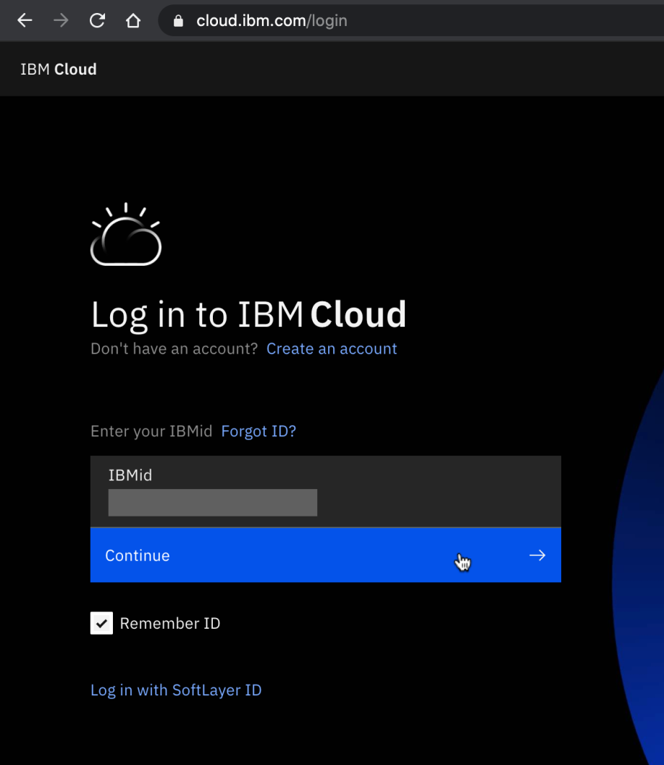

1. Enter your **password** and click **Log in**.

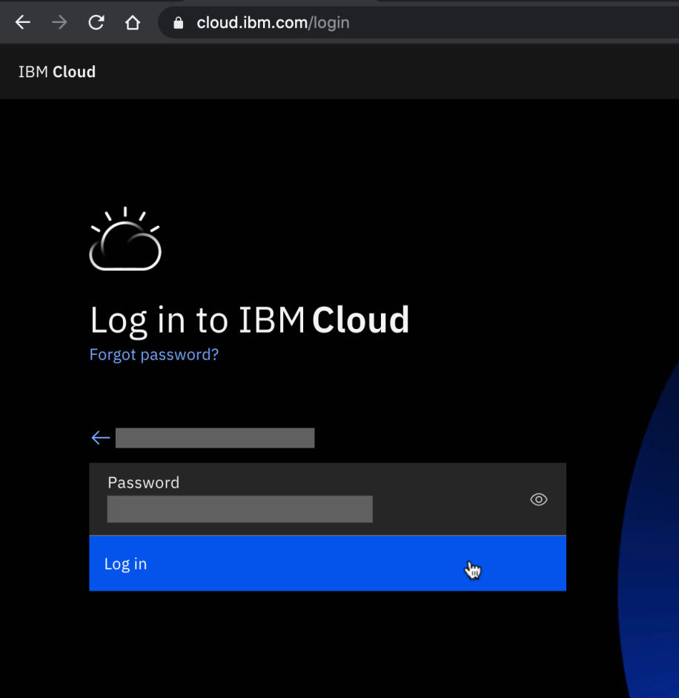

1. Click **Navigation Menu Icon** on the top left side.

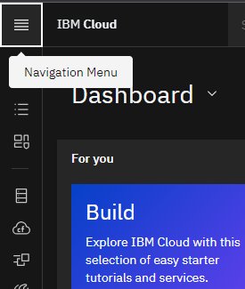

1. From the navigation Menu sidebar, click **Watson**.

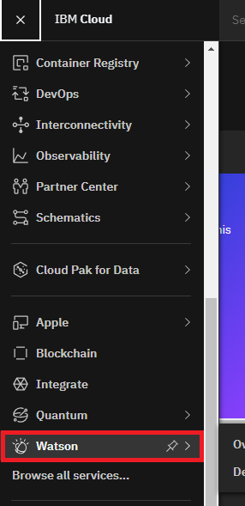

1. Now from the section **All Services**, click Watson Studio **Start free plan**. You will see a dialog box to enter the region and the name of your Watson Studio instance.

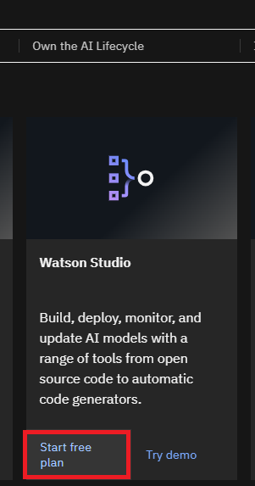

1. **Select a region** matching the region of your IBM Cloud account and provide a name for your Watson Studio instance. Click on the Create button.

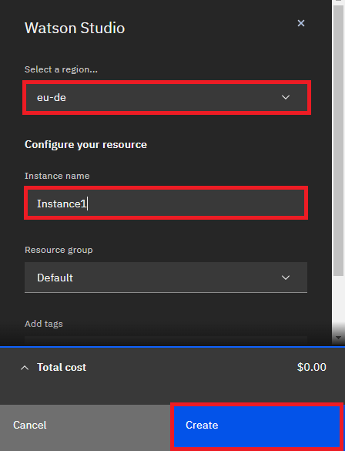

1. You will be redirected to IBM Cloud Pak ([dataplatform.cloud.ibm.com](https://dataplatform.cloud.ibm.com/?utm_source=skills_network&utm_content=in_lab_content_link&utm_id=Lab-IBM-DA0321EN-SkillsNetwork)) for Data platform. In case you are not redirected to IBM Cloud Pak page, you need to go to the Resource List from the Navigation Menu.

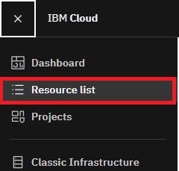

1. Select your Watson Studio instance from the AI/Machine Learning section.

<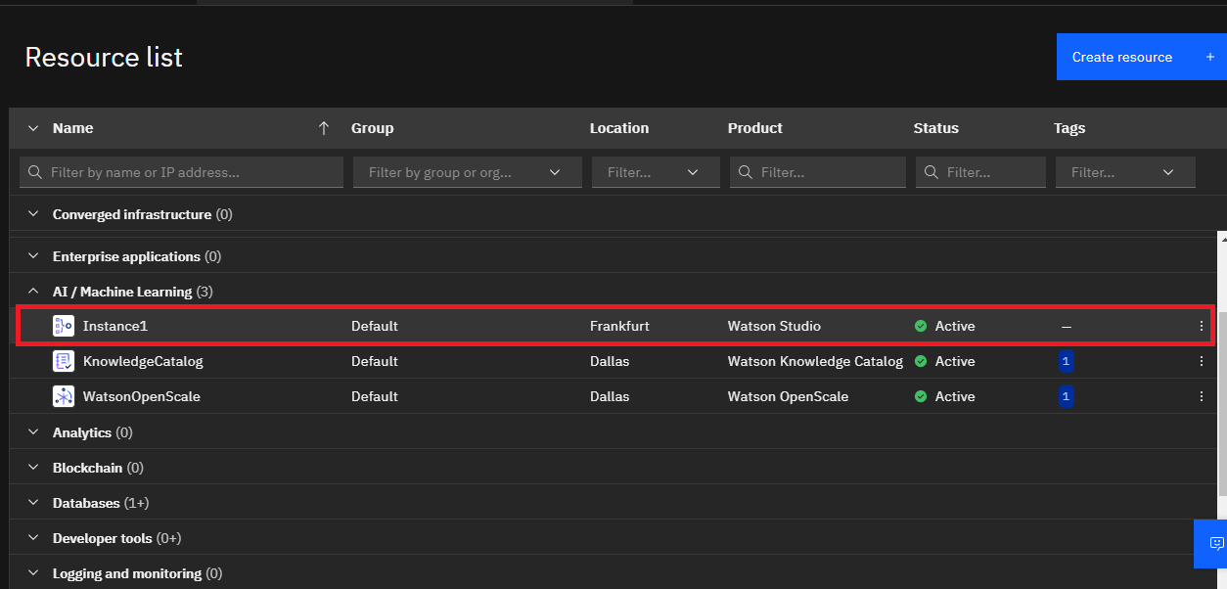

1. Click on **Launch in IBM Cloud Pak for Data**.

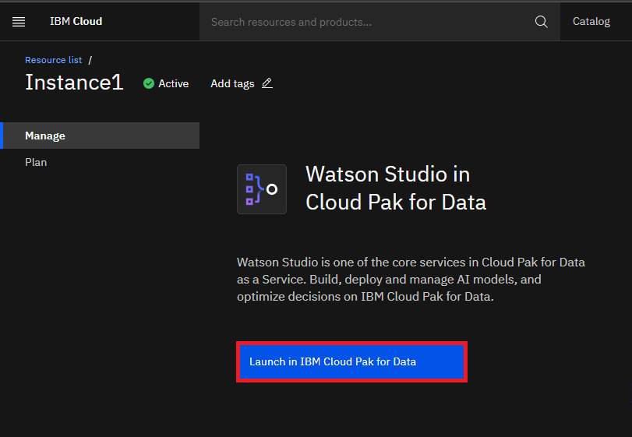

1. You will be redirected to [IBM Cloud Pak for Data](http://dataplatform.cloud.ibm.com/?utm_source=skills_network&utm_content=in_lab_content_link&utm_id=Lab-IBM-DA0321EN-SkillsNetwork)

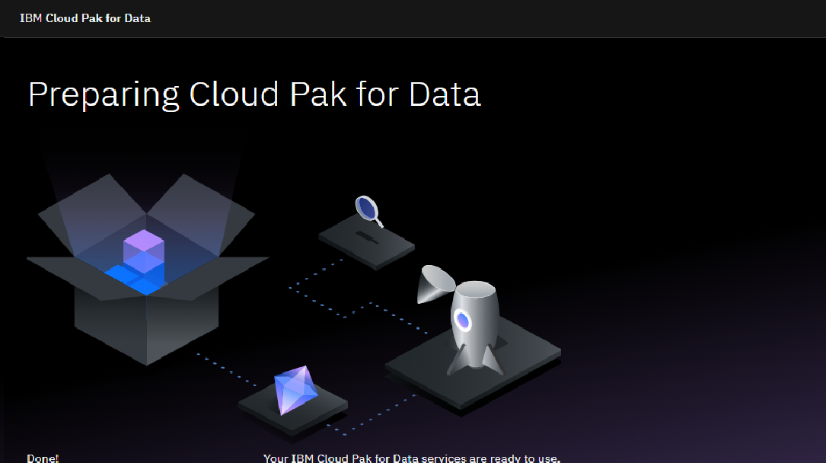

1. You have successfully logged in to the IBM Cloud Pak for Data platform.

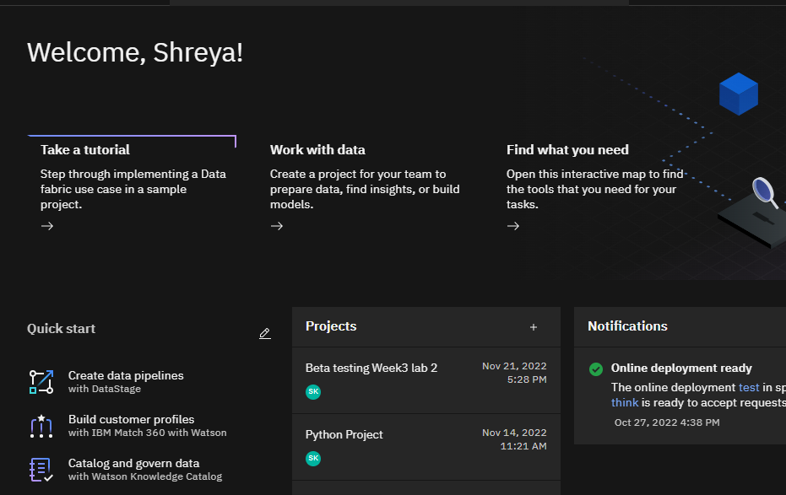

**Task B : Login to IBM Cloud Pak for Data**

* **If you just completed Task A, you will already be logged in, so skip Task B.**

1. Go to [dataplatform.cloud.ibm.com](https://dataplatform.cloud.ibm.com/?utm_source=skills_network&utm_content=in_lab_content_link&utm_id=Lab-IBM-DA0321EN-SkillsNetwork).
2. Enter your **IBMid** (the email ID you used to sign up for IBM Cloud), **password** and select a **region**, same one you used for IBM Cloud account and IBM Cloud Pak for Data(if you have completed Task A).

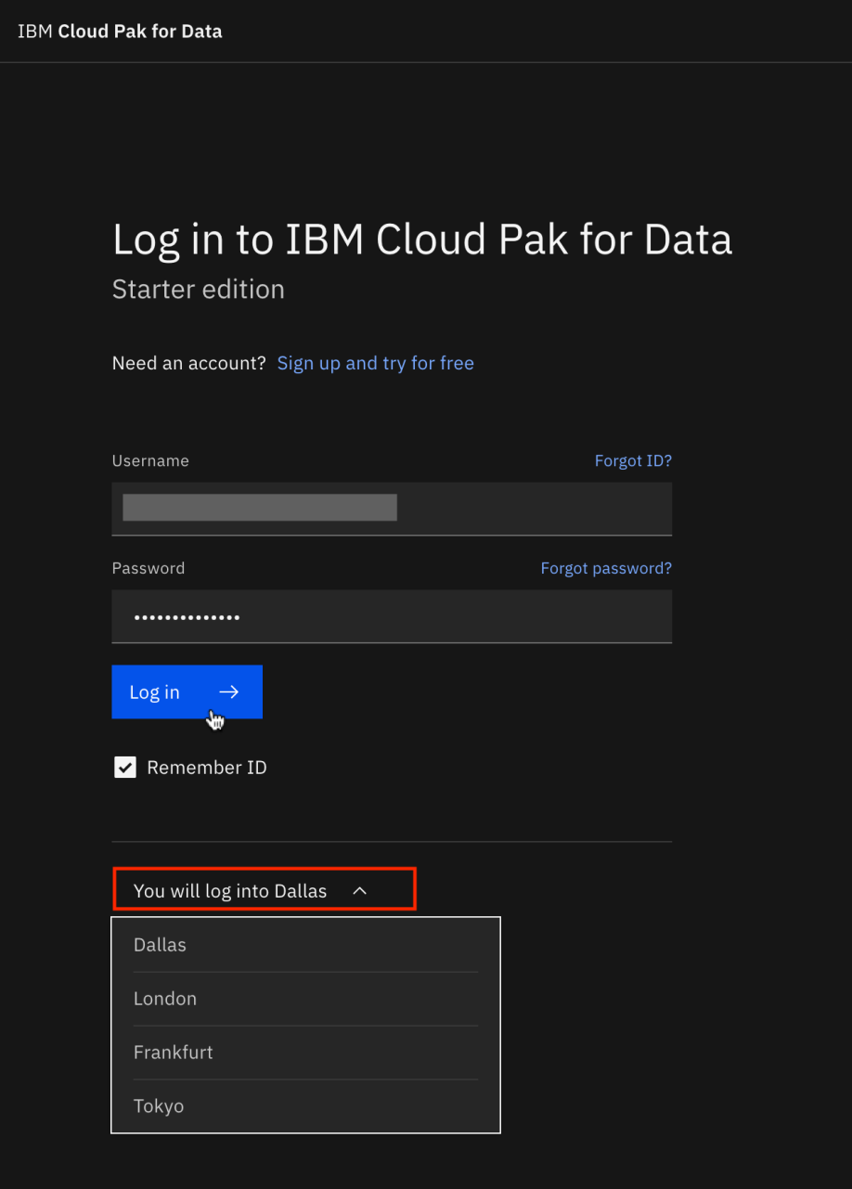

1. Click **Go to IBM Cloud Pak for Data**.

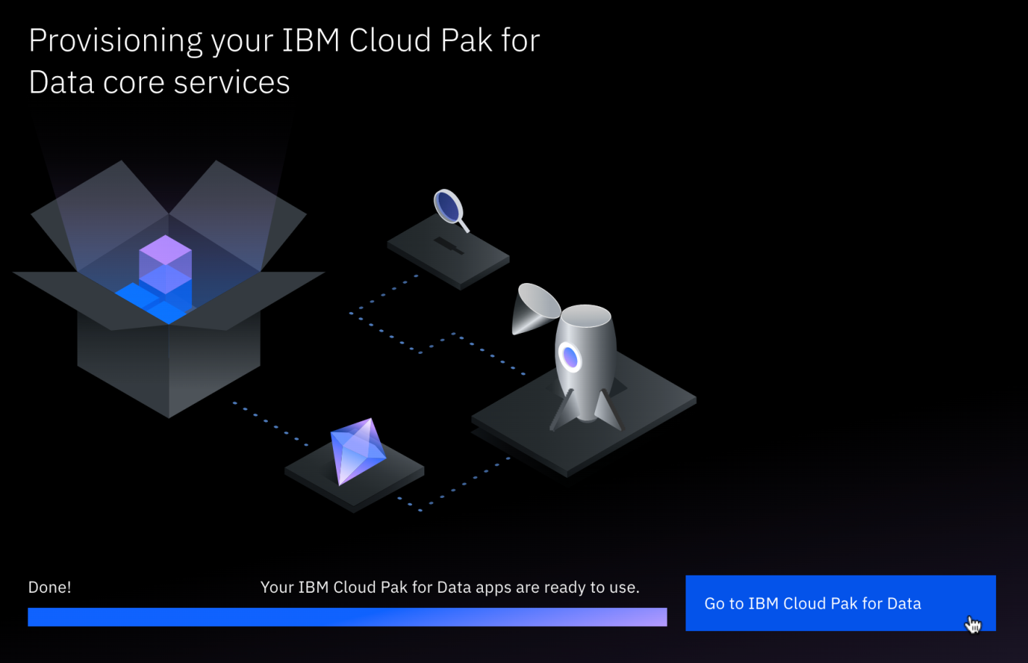

1. You have successfully logged in to the IBM Cloud Pak for Data platform.



**Task C : Create a New Project**

1. On the IBM Cloud Pak for Data welcome page, click **Create new project**.

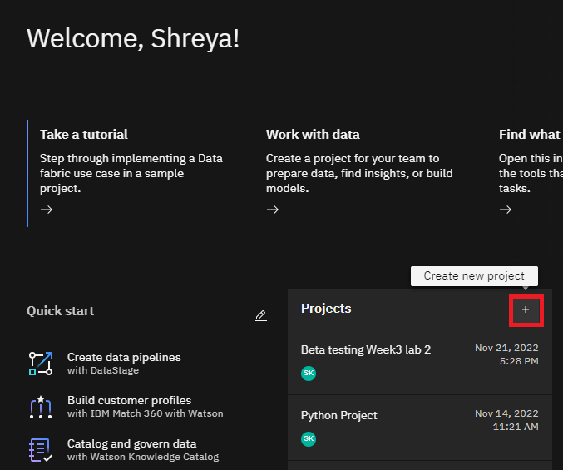

1. Click **Create an empty project**.

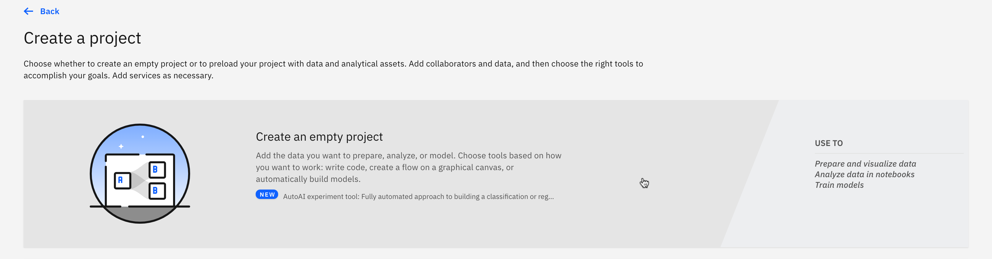

1. Write **Capstone Project** as name of the project and click **Add** on Select storage service if no storage service appears. If a storage appears, proceed to step 6 directly.

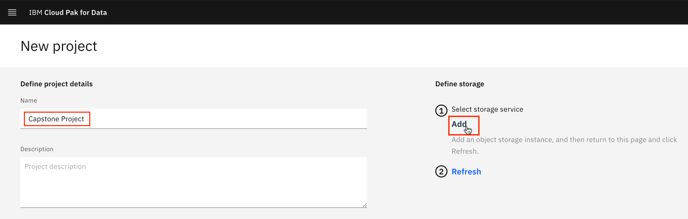

1. You will be redirected to a new page. On the **Create** tab, select **Lite** plan. Then click **Create**.

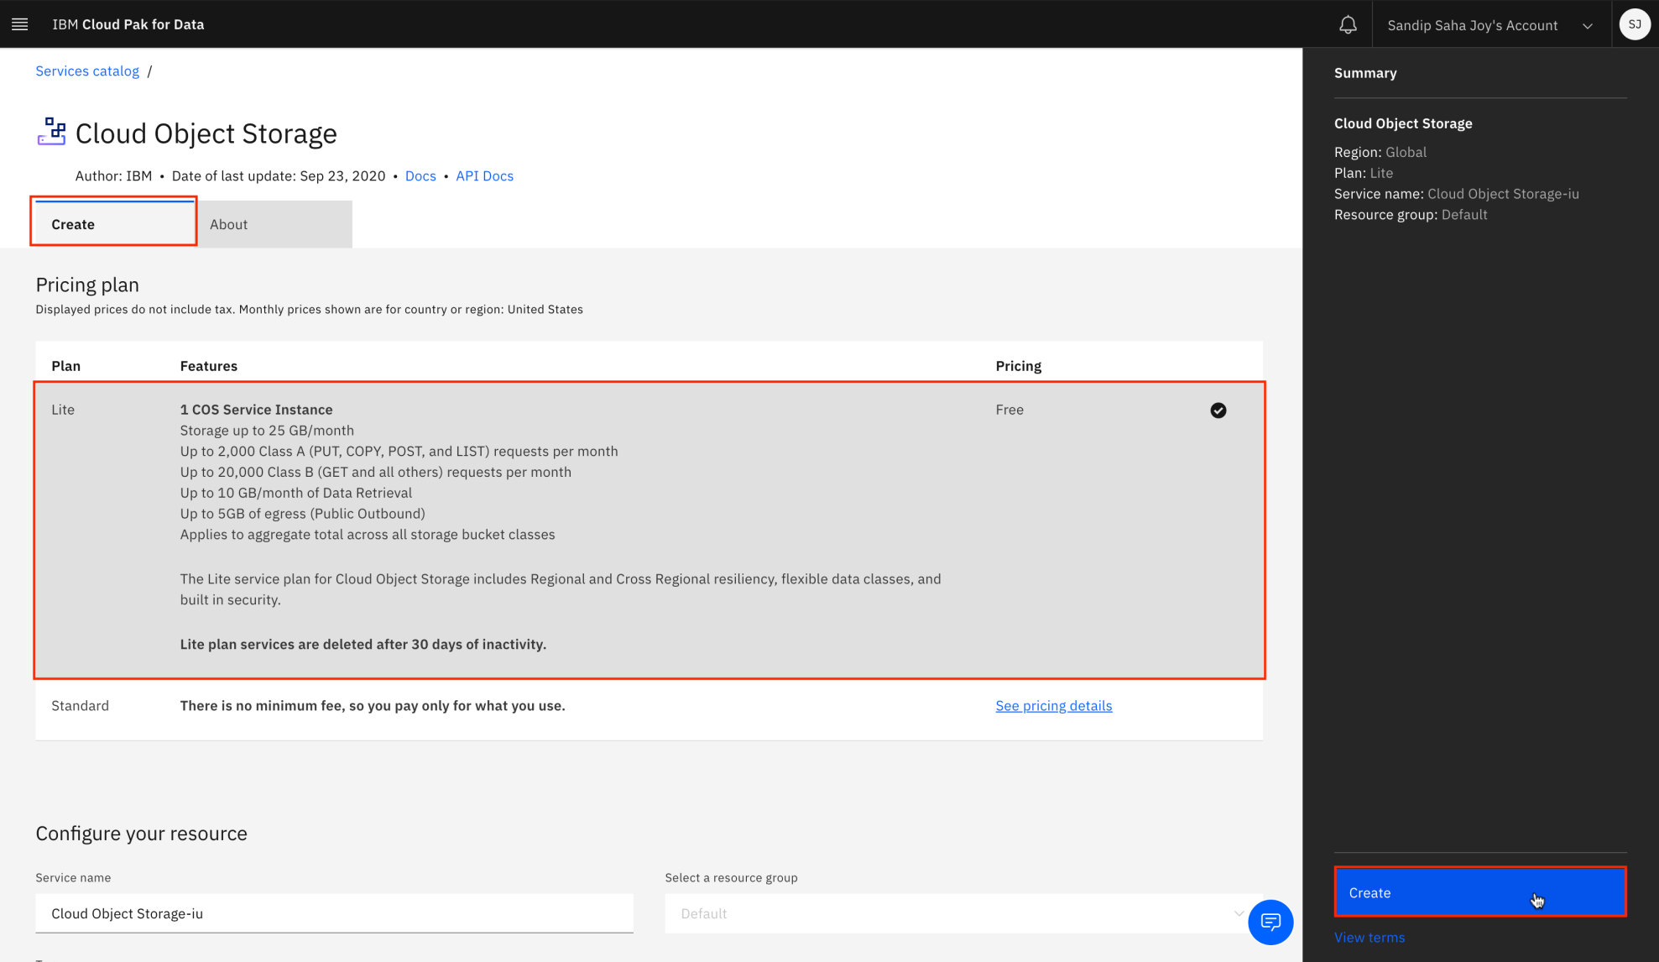

1. Now you will be redirected to the previous new project page. Click **Refresh**.

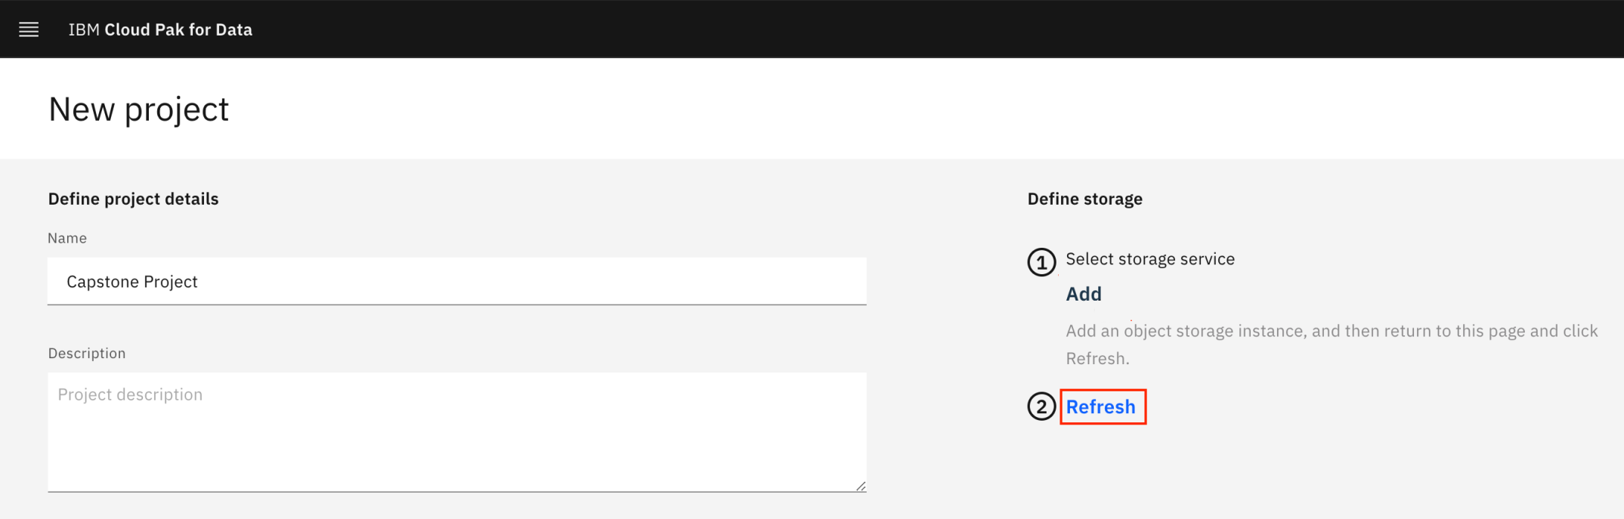

1. Once you see a storage service, click **Create**.

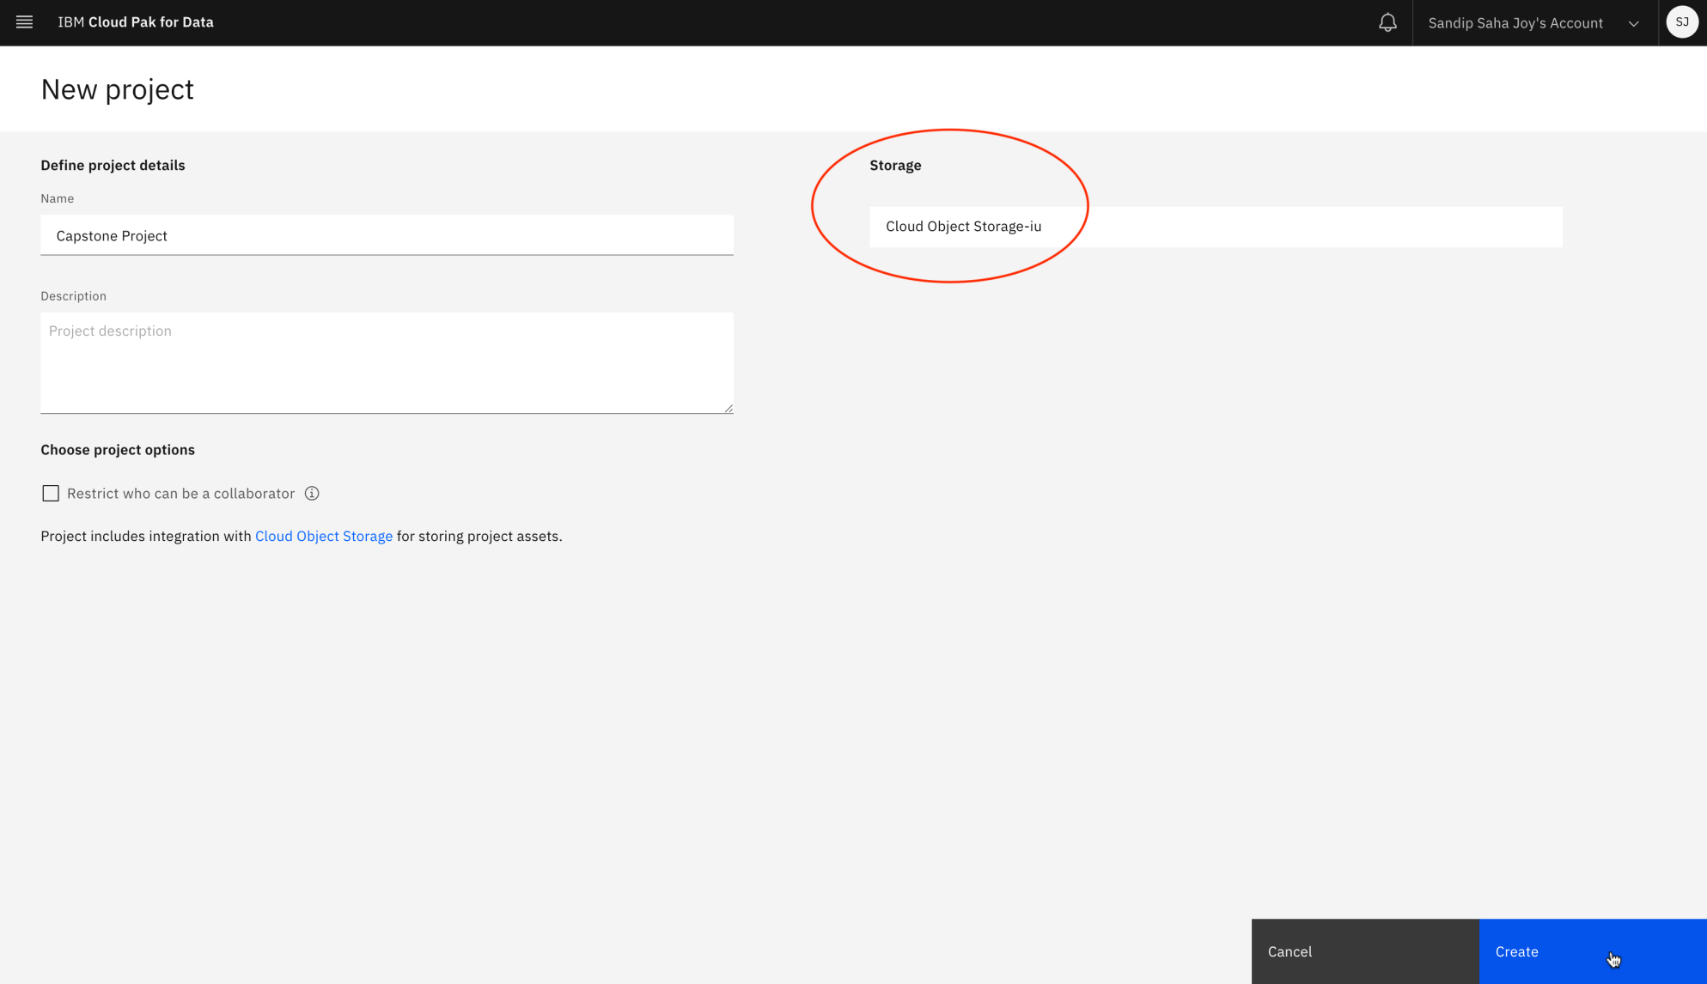

1. You have successfully created a project. Click **IBM Cloud Pak for Data** at the top left to go back to homepage.

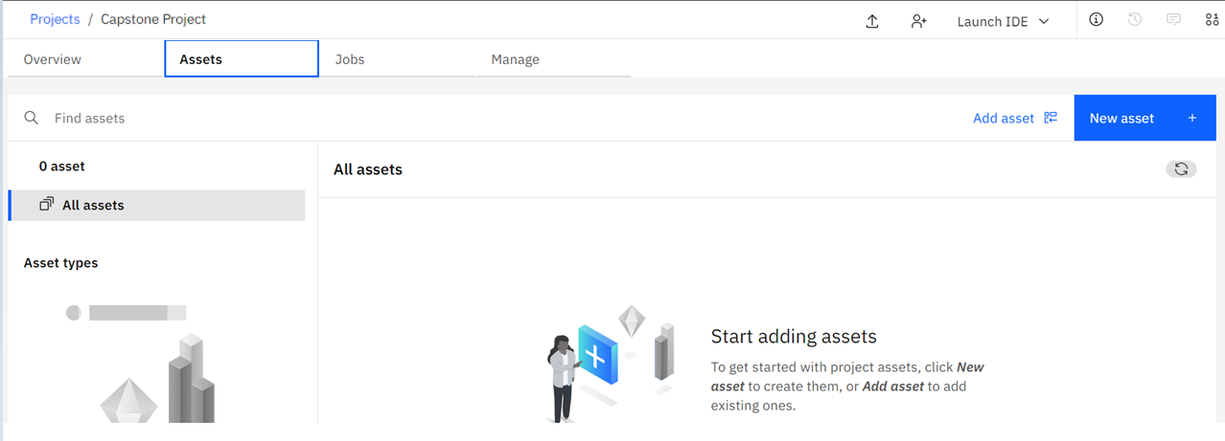

**Exercise 2 : Add a CDE service and Upload External Data**

In this exercise, you will learn how to add a Cognos Dashboard Embedded (CDE) service and upload external data files to your project.

**Task A : Add a CDE service**

1. From IBM Cloud Pak for Data homepage, got to **Projects** under Quick navigation and click on the Capstone project you had created earlier

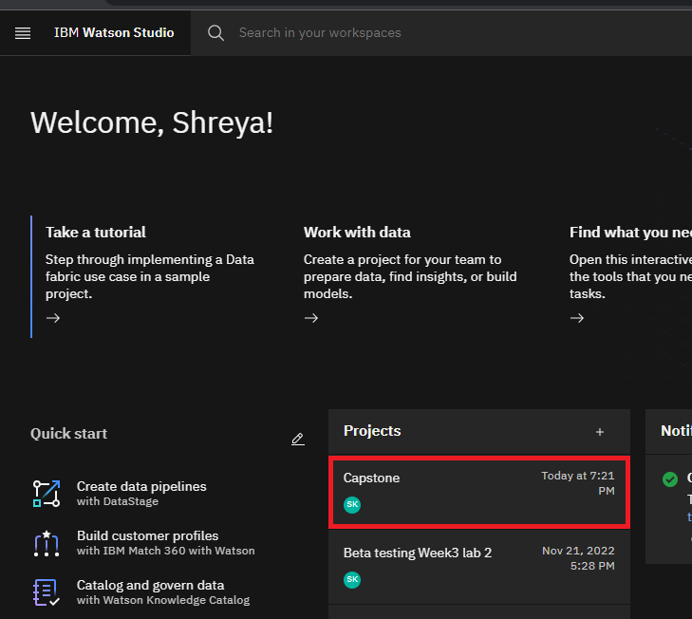

1. Click on **Manage** tab , from the **Services and integrations** section click **Associate service**

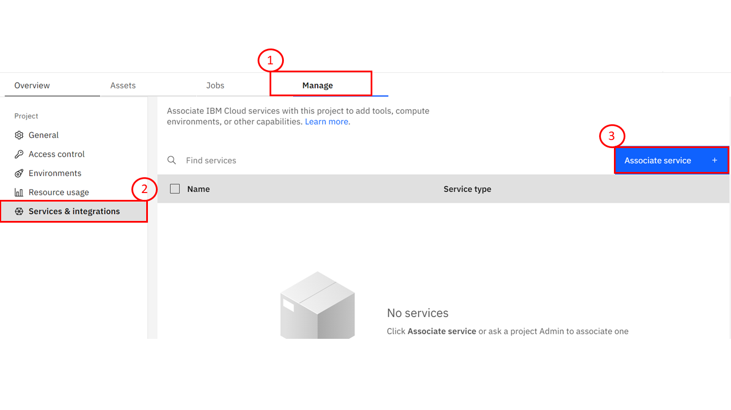

1. Click **New service**.

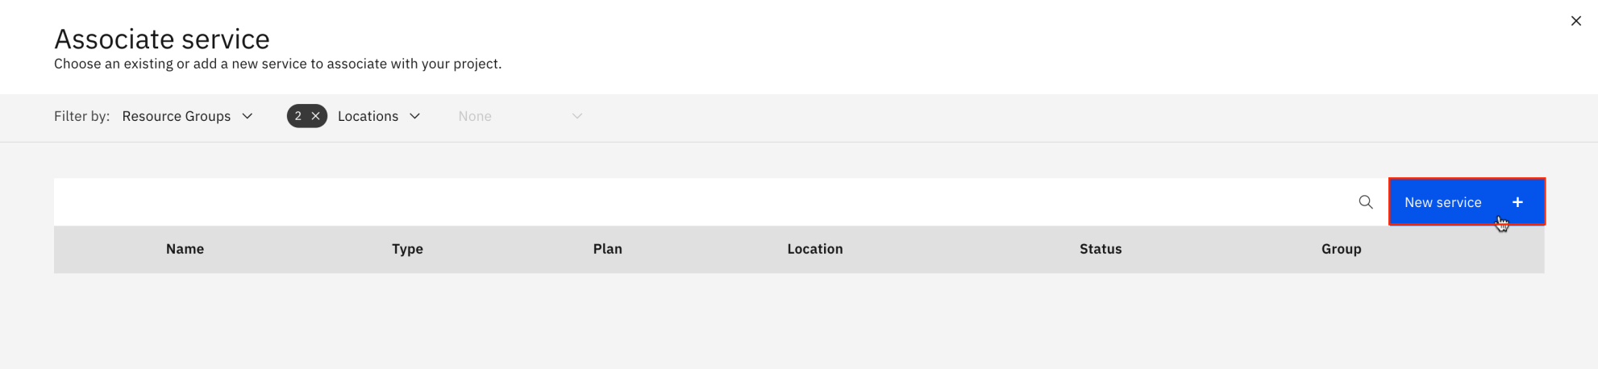

1. Click **IBM Cognos Dashboard Embedded**.

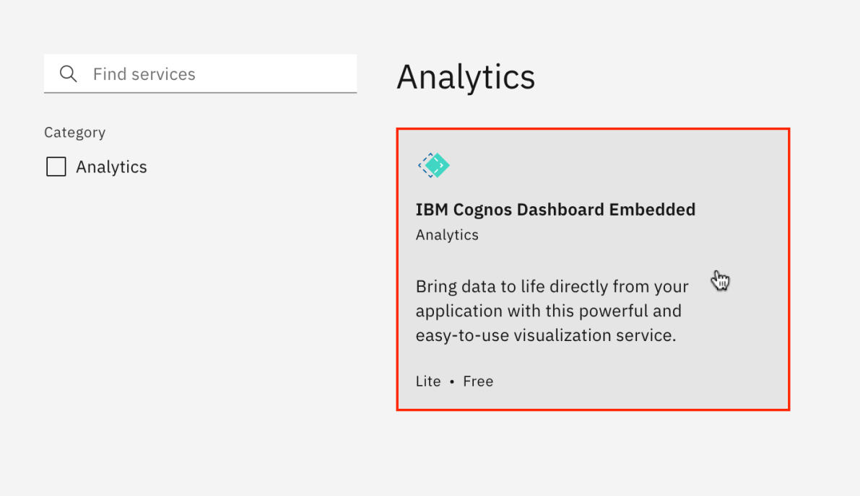

1. On the **Create** tab, select a **region** and **Lite** plan. Then click **Create**.

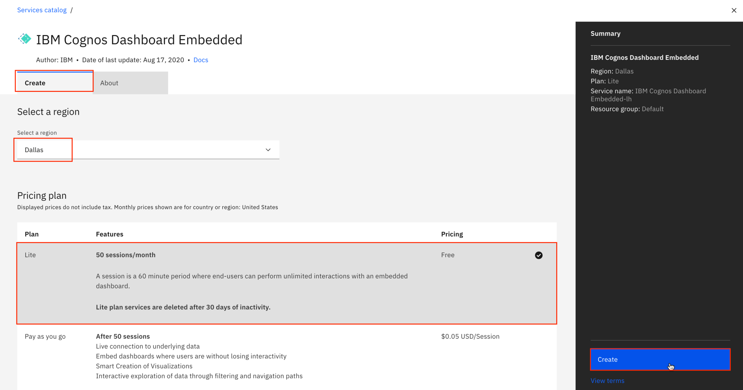

1. Select **IBM Cognos Dashboard Embedded** service and click **Associate service** to add the service to **Capstone Project**.

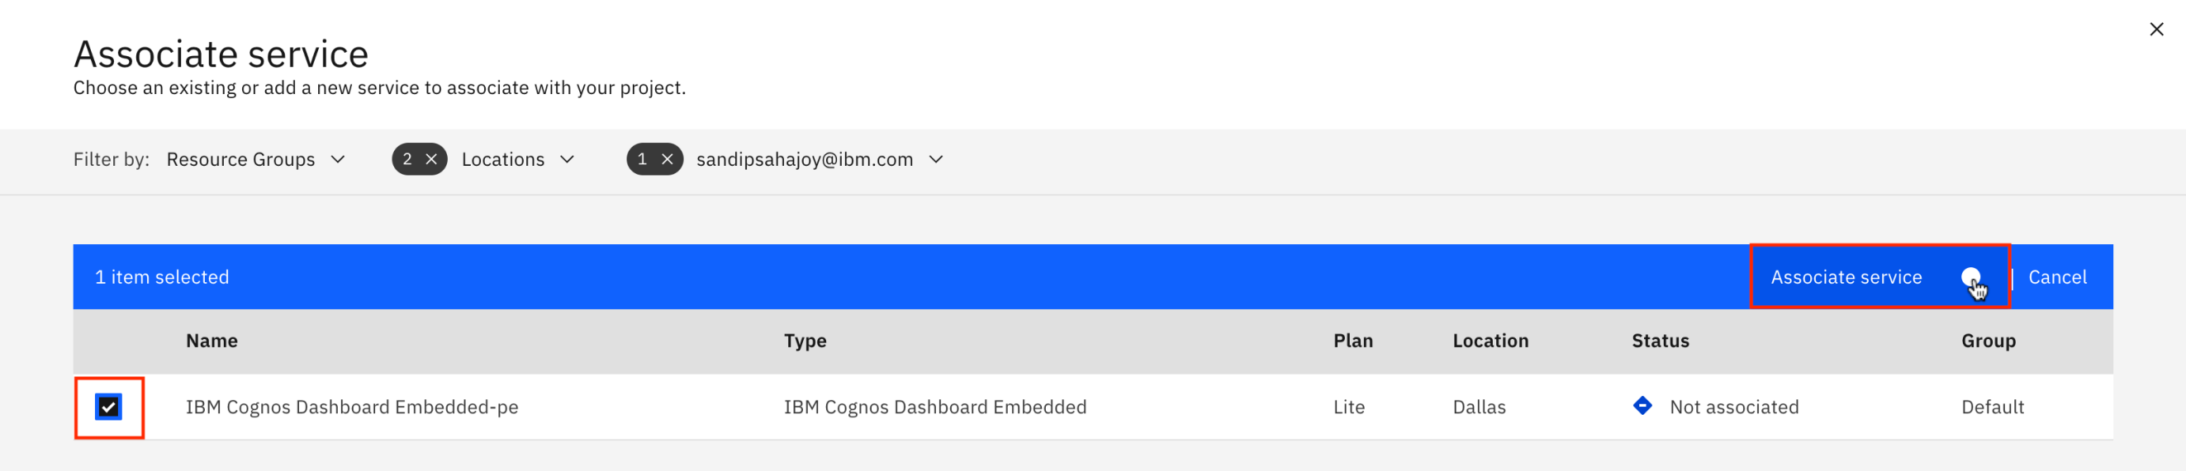

1. Once the service association status appears green, **close** the associate service page.

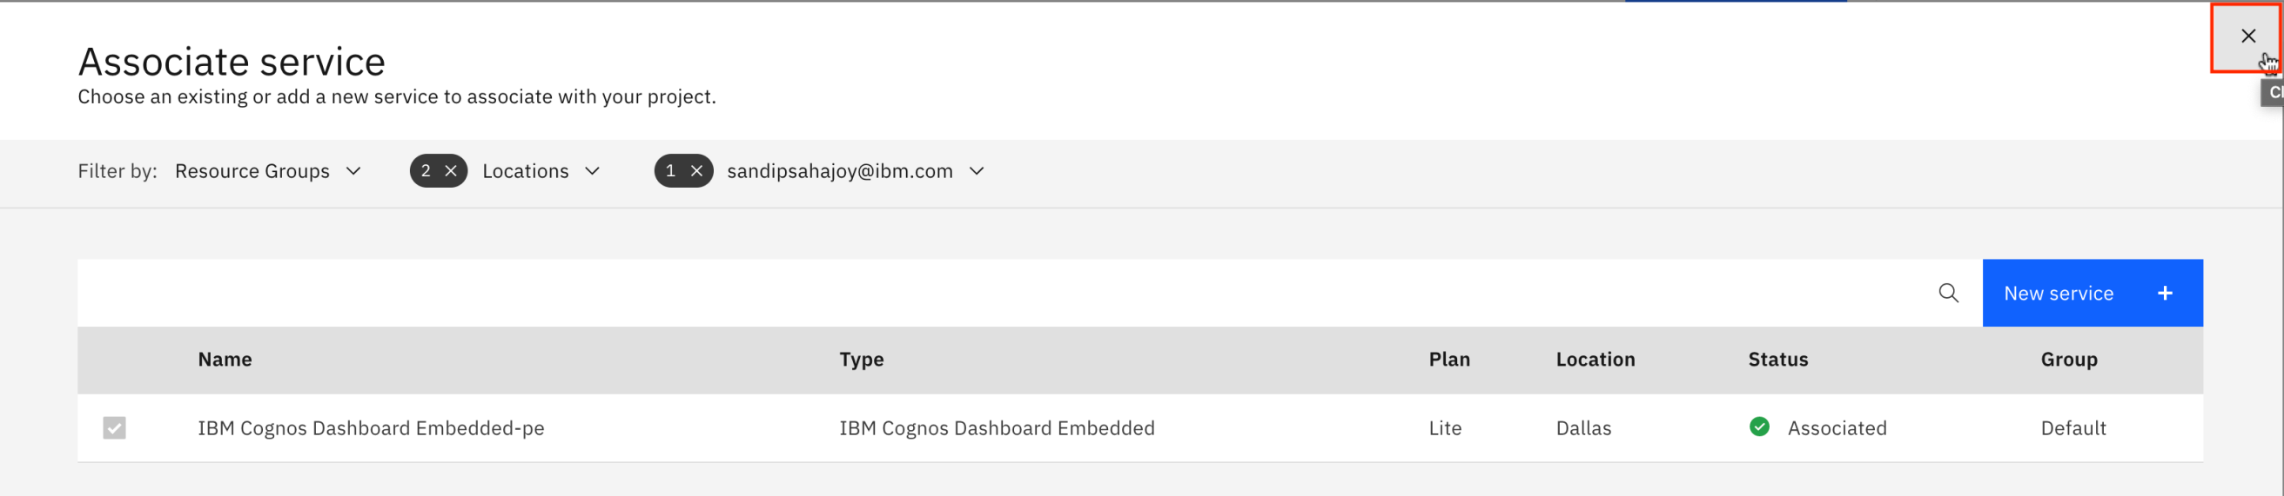

**Task B : Upload External Data Files(Supports .CSV Files Only)**

1. Download the file [car_sales_data_sample.csv](https://cf-courses-data.s3.us.cloud-object-storage.appdomain.cloud/IBM-DA0321EN-SkillsNetwork/labs/module%205/Lab%20-%20Getting%20Started%20with%20Cognos%20Dashboard%20Embedded/car_sales_data_sample.csv).
2. On the **Assets** page, click **Find and add data** icon. Click **Drop data files here or browse for files to upload**.

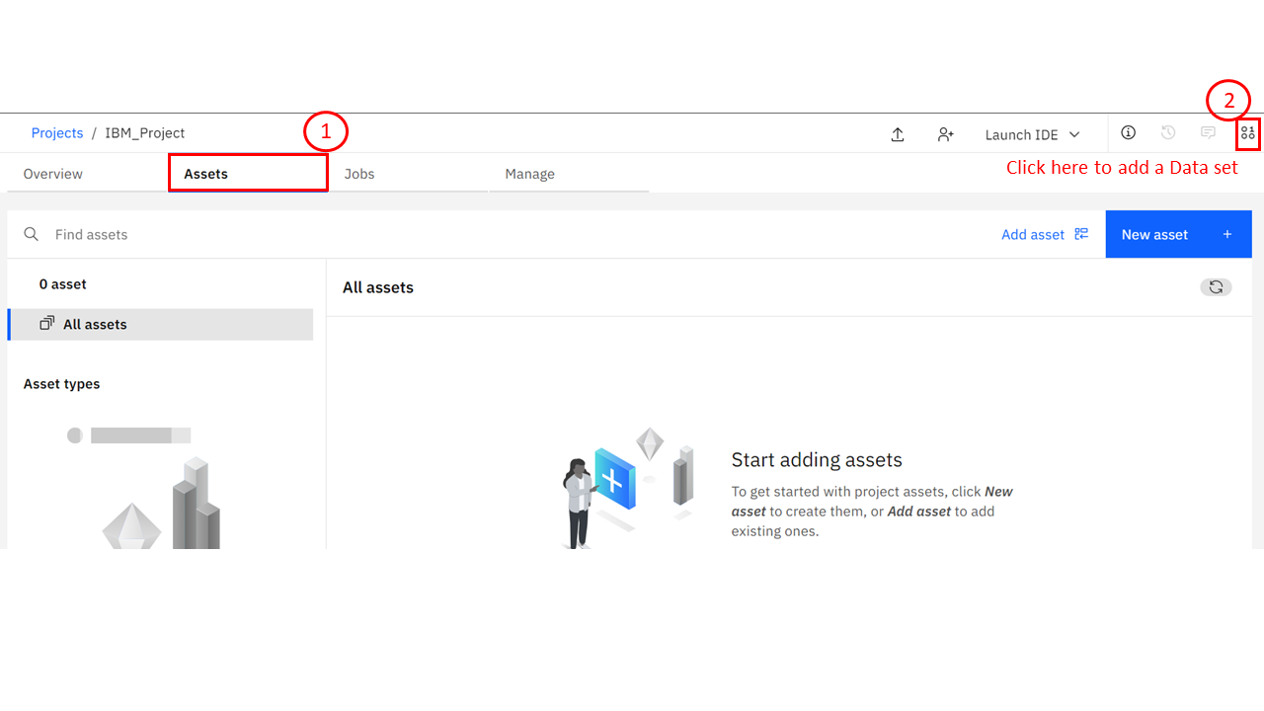

1. Browse to the file download location, select the downloaded **CSV** file, and click **Open**.
2. Once upload completes, **car_sales_data_sample.csv** will appear under **Data assets** section.

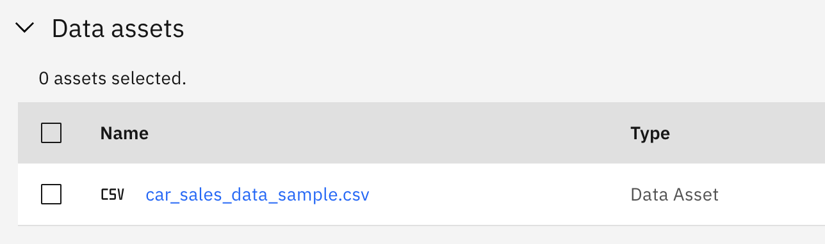

**Exercise 3 : Navigate around CDE UI and Start a New Dashboard with a Template**

In this exercise, you will learn general navigation around the CDE user interface (UI), and how to start a new dashboard with a template in CDE, populate it with a data visualization as well as save the dashboard.

1. On the **Overview** page of Capstone Project project, click **New asset**.

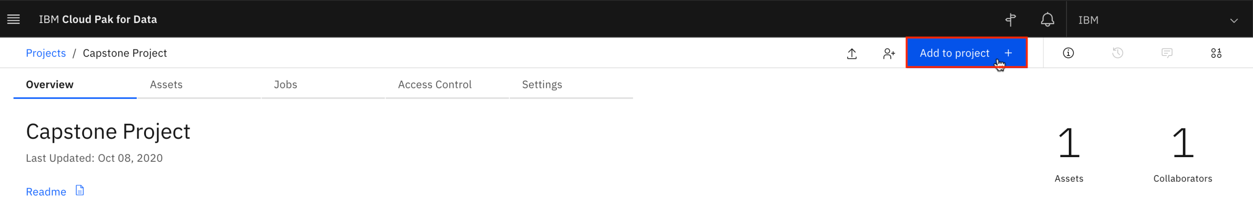

1. Scroll down and select **Dashboard Editor**.

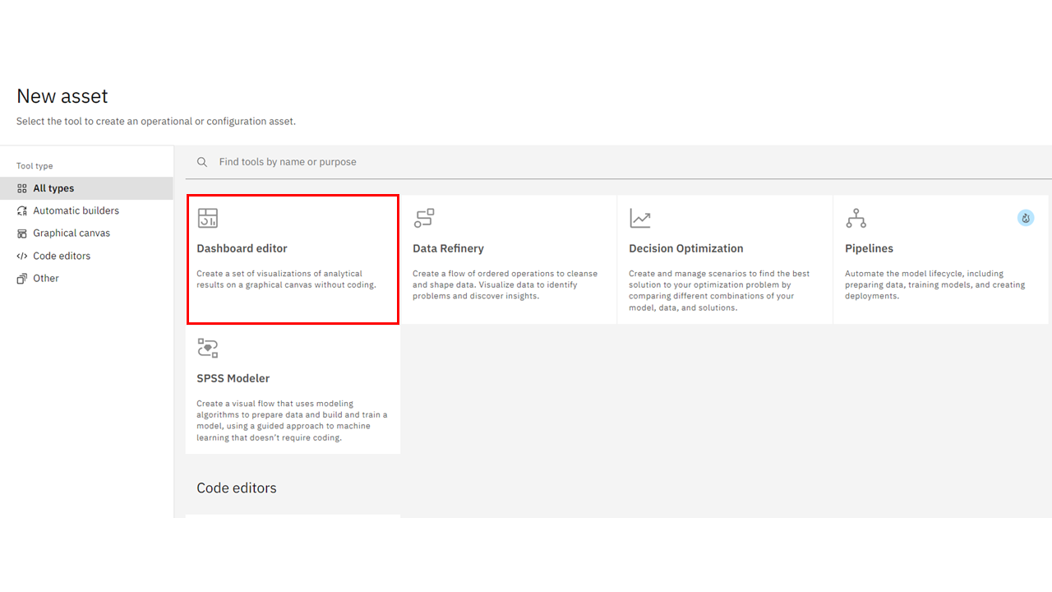

1. Name the dashboard as **Simple Dashboard**. Then select a **Cognos Dashboard Embedded service** from the list and click **Create**.

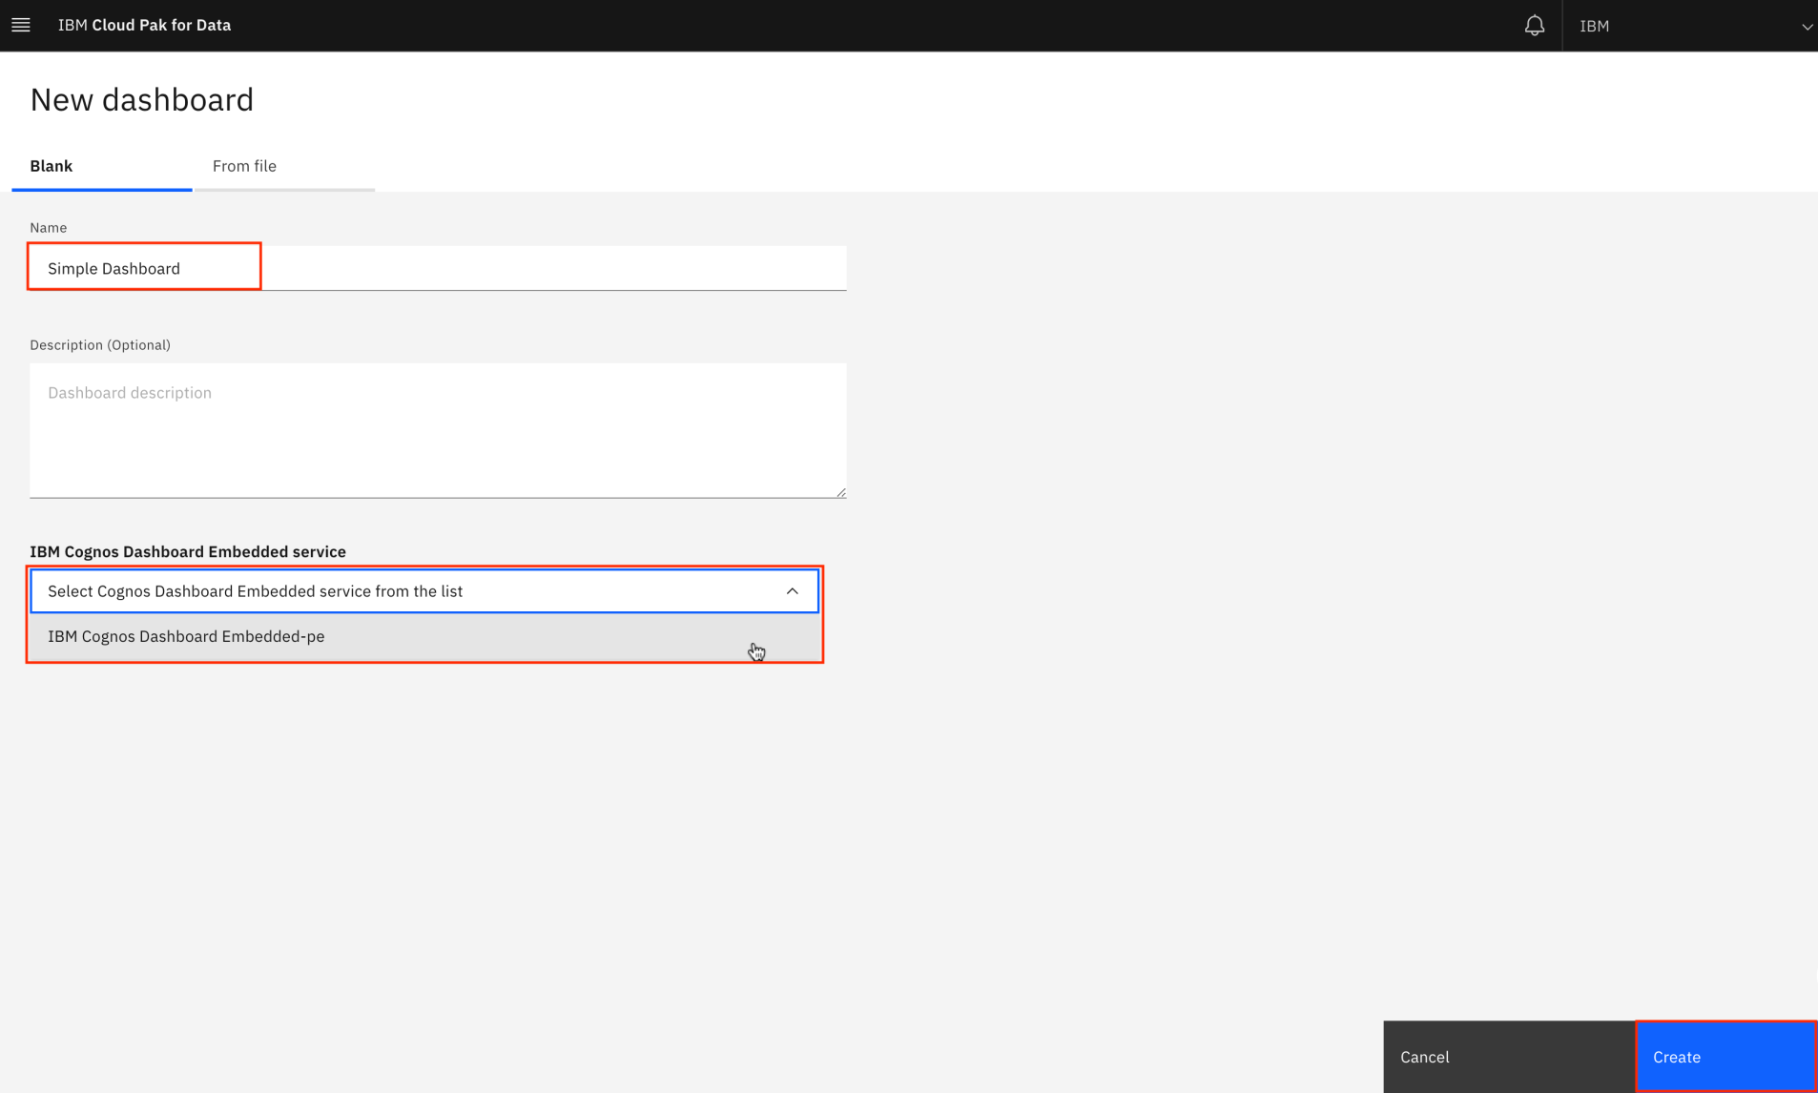

1. Select the **tabbed dashboard style**. This will allow you to have multiple pages for your dashboards. Select the **one-panel template**. Click **OK**.

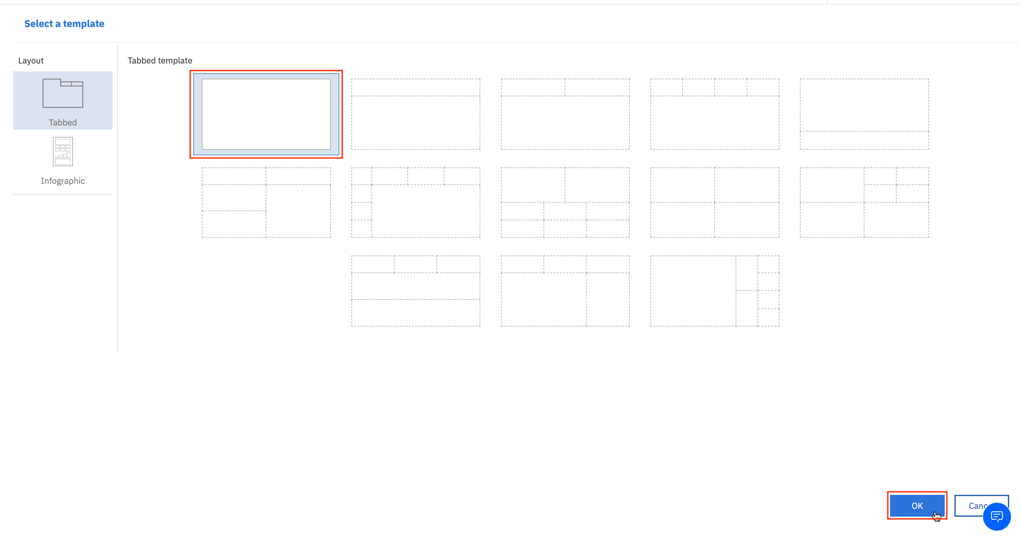

1. Now you have created a new dashboard using the dashboard template.

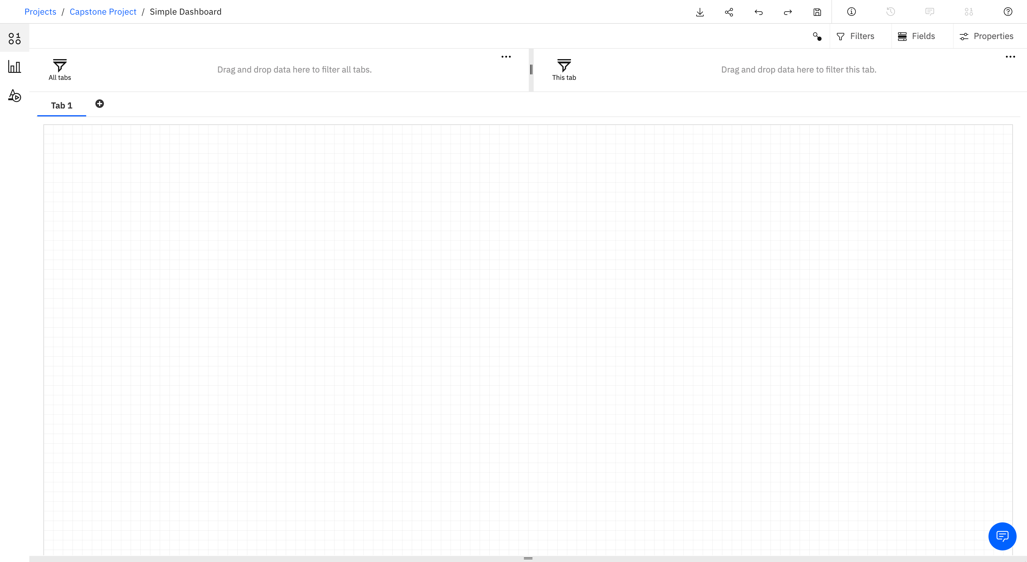

1. Click **Sources** icon from the **Navigation** panel to open the data source panel. Then click **Add a source** icon.

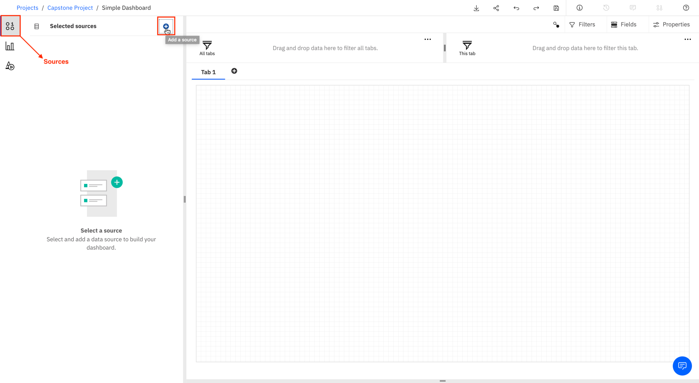

1. Select **Data assets**. Select **car_sales_data_sample.csv** and click **Select**.

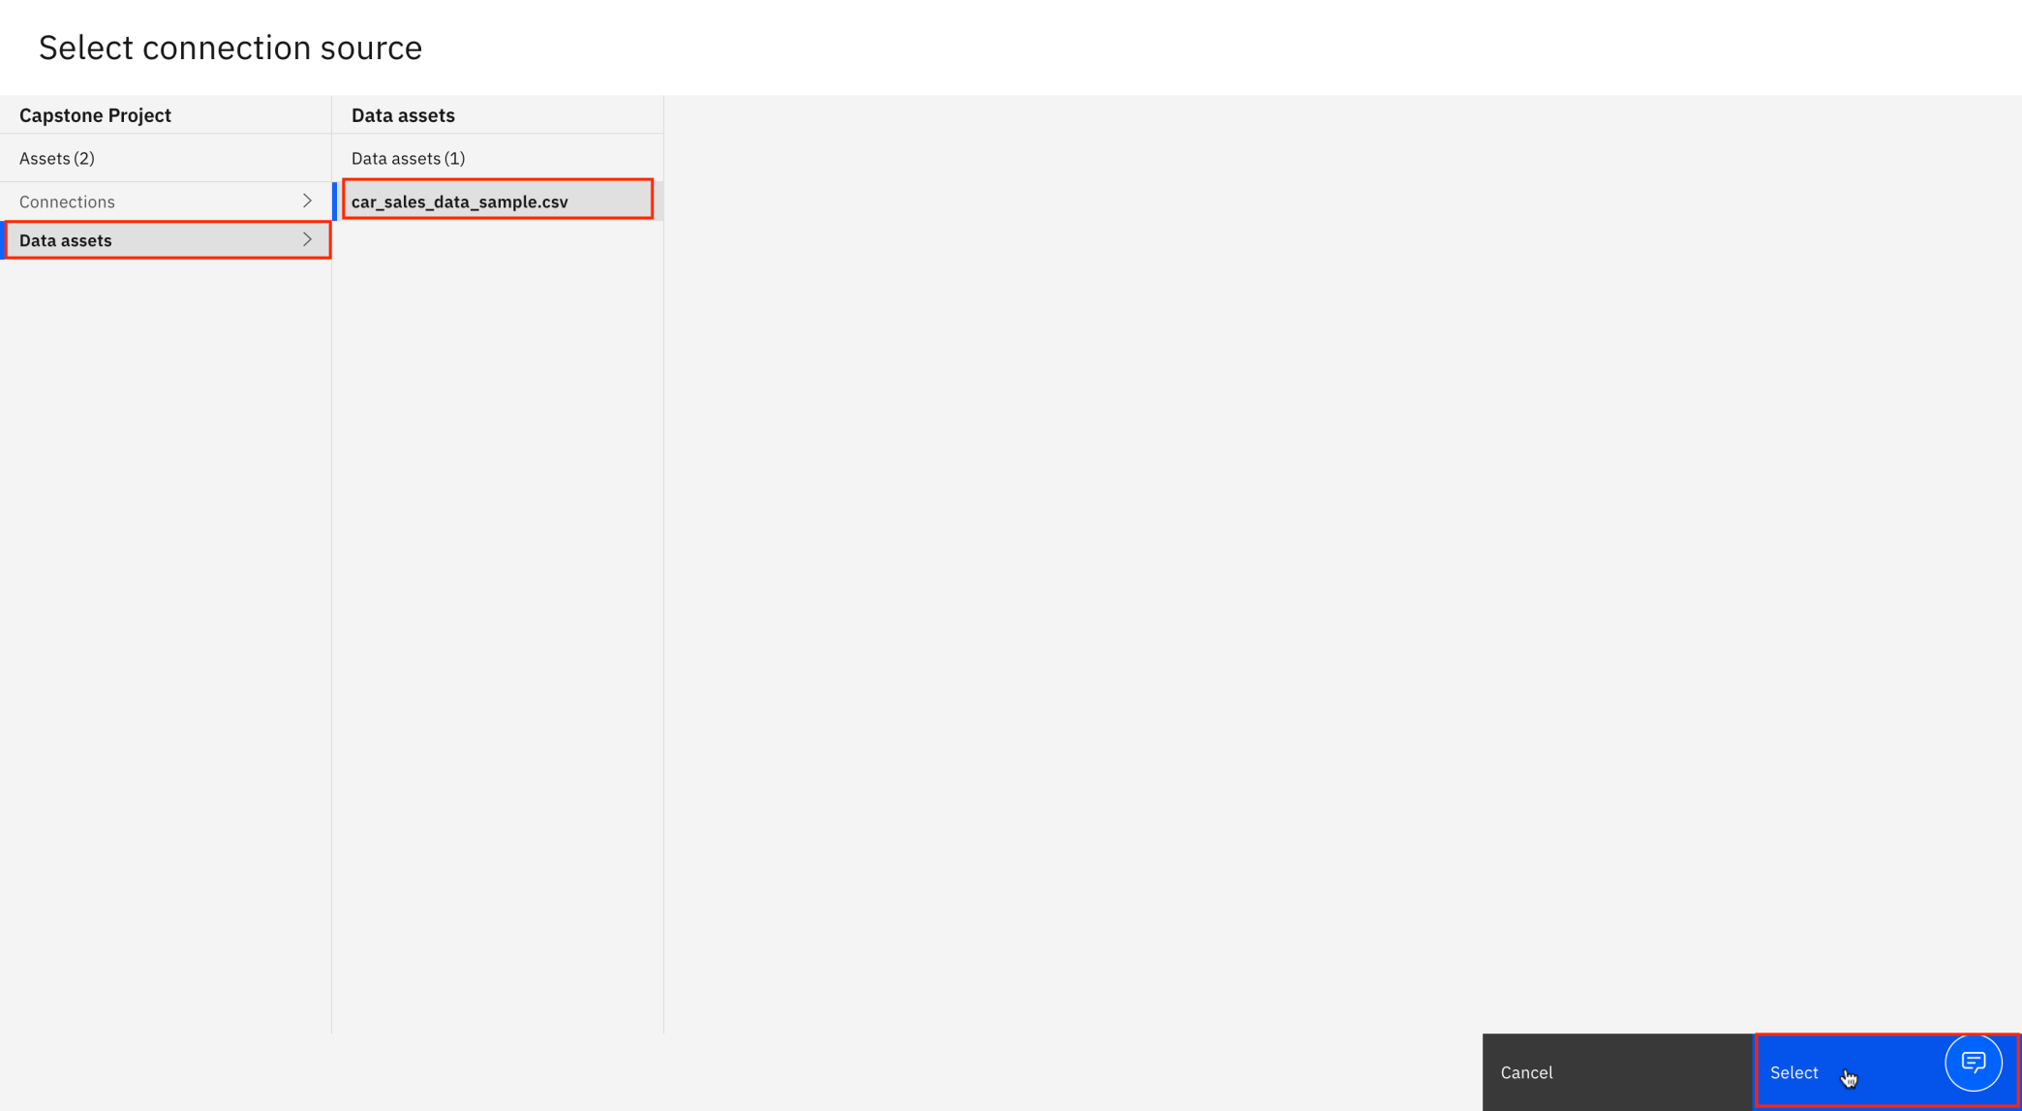

1. From the **Navigation** panel, select **Sources** to open the data source panel, if it is not already open. The **Data Source** panel displays the file **car_sales_data_sample.csv**. Click on **car_sales_data_sample.csv**.



1. From the **Data Source** panel, select **SALES**. Drag it to the **Panel** and release.

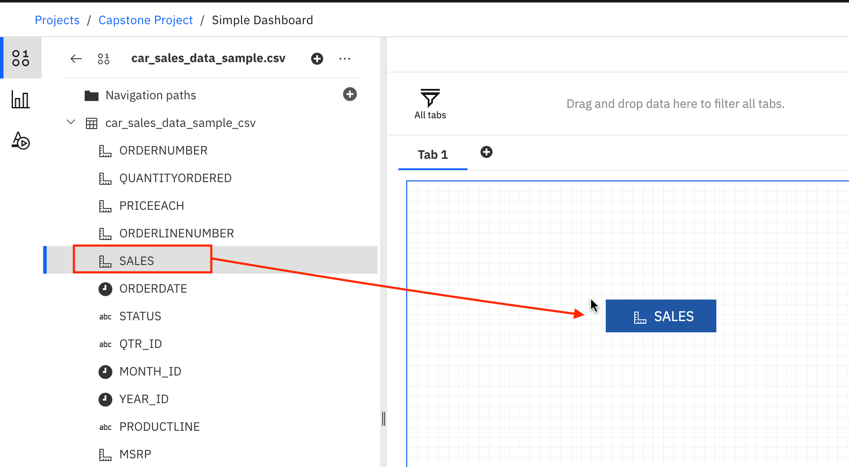

1. Now you have successfully started to populate your dashboard with data visualizations too!

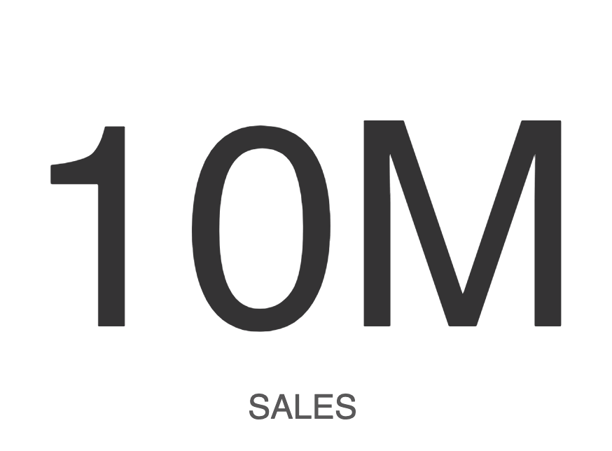

1. To save the newly created dashboard, click **Save** icon.

